**ThinBackup Plugin**

**1. Log into your jenkins console**

* **Got to manage Jenkins**

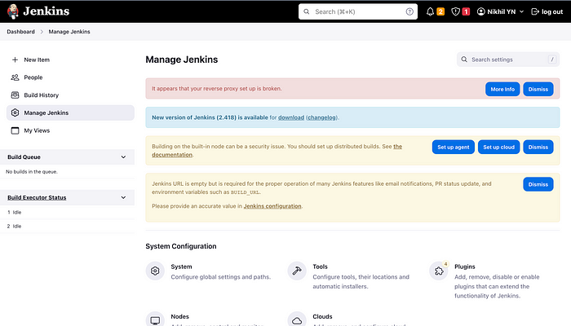

* **Go to plugins > Available Plugins > Search for ThinBackups > click Install**

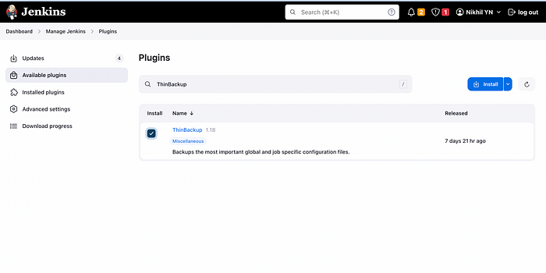

* **After installation, click on Restart button**

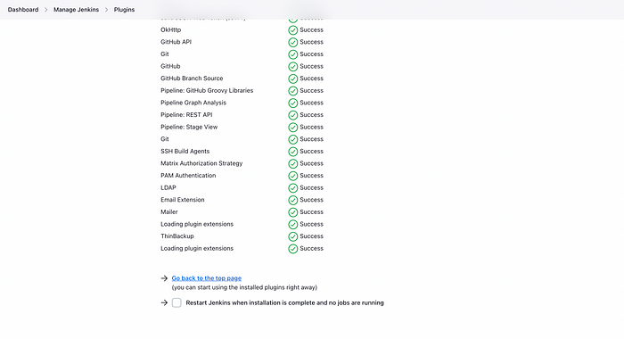

* **Jenkins will re-start**

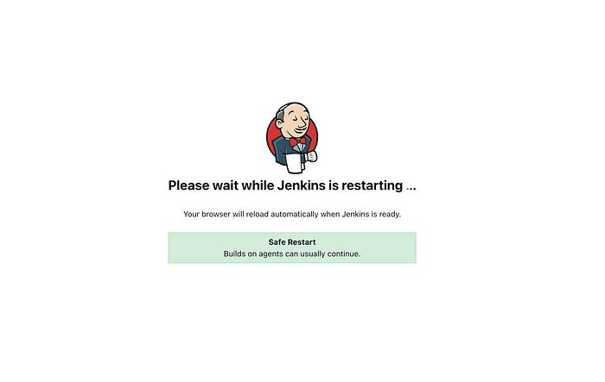

* **Verify under installed plugin section whether ThinBackup is installed or not**

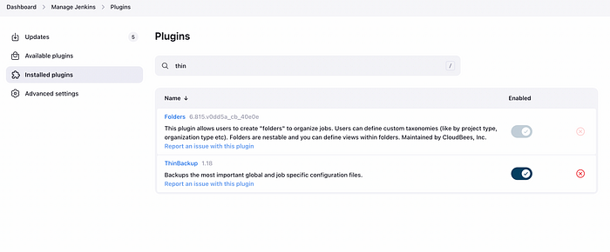

* **Go to Dashboard > Manage Jenkins > Tools and Actions > ThinBackup is available**

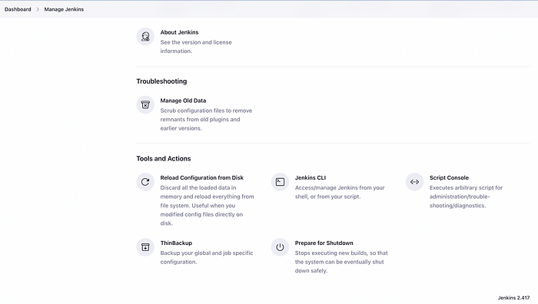

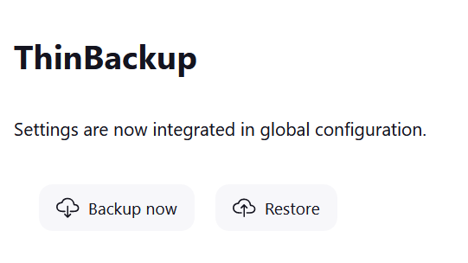

* **For configuration go to manage Jenkins > System Configuration> System**

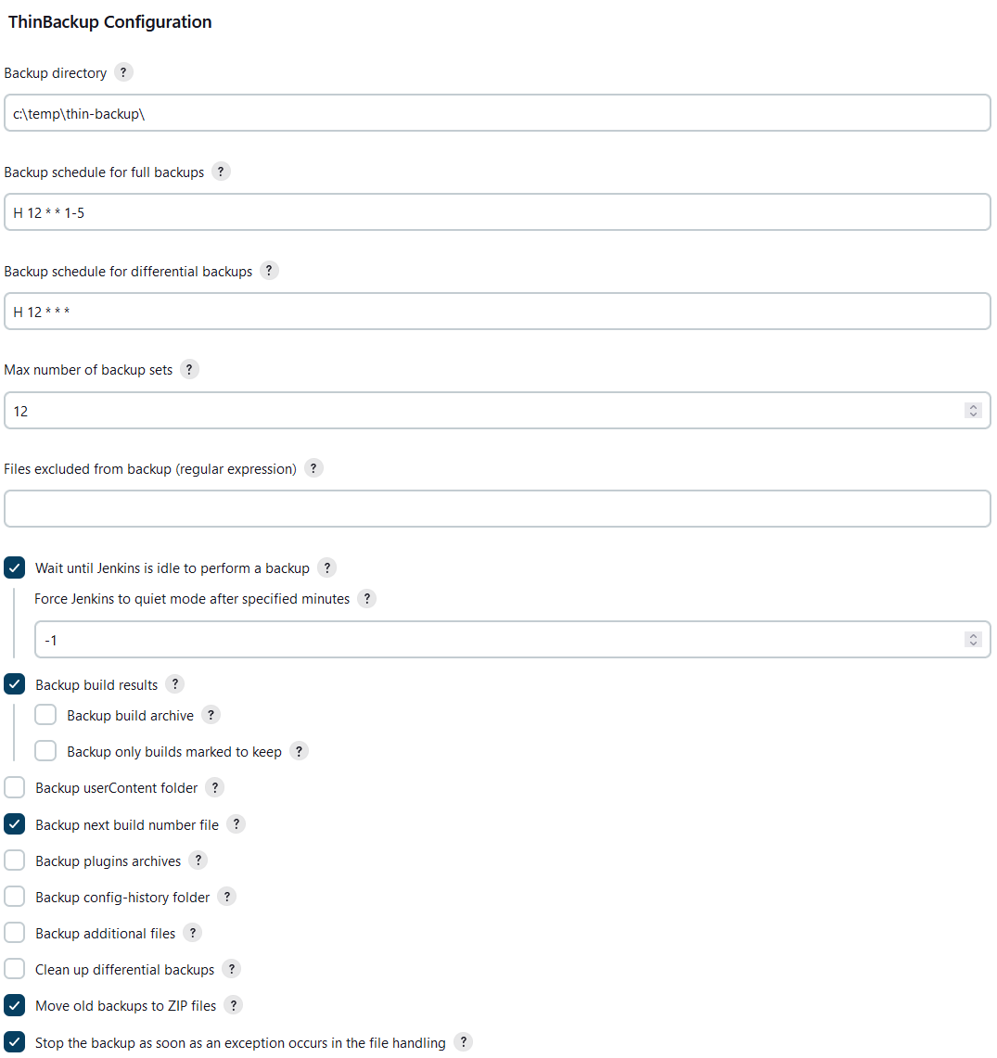

**When I had given the path of backup directory , I got this below error**

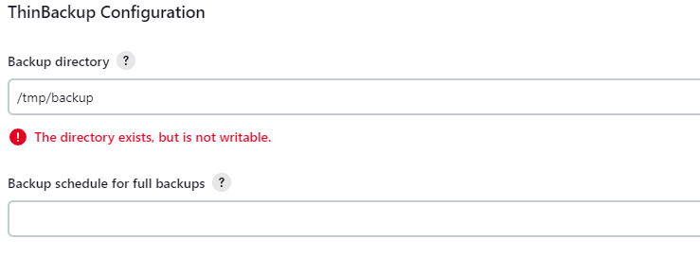

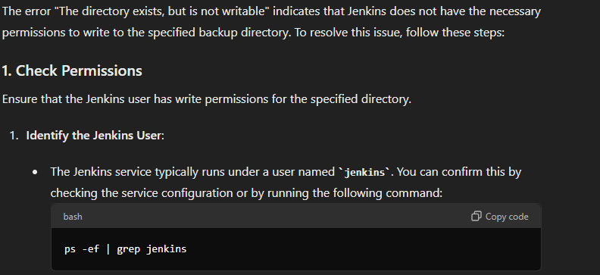

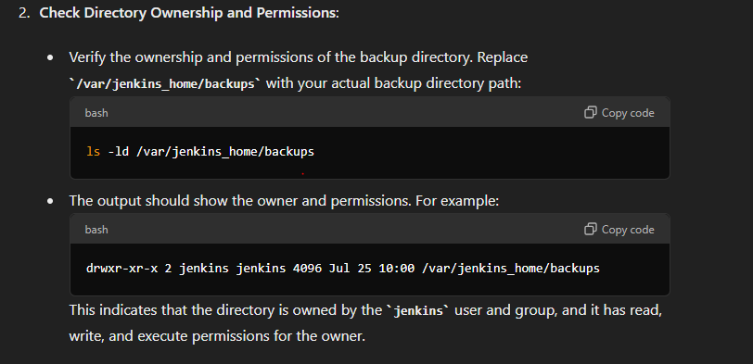

**For me ownership and permissions is managed by ec2-user**

This means the ec2-user needs to have write permissions for the backup directory. Here's how you can ensure that:

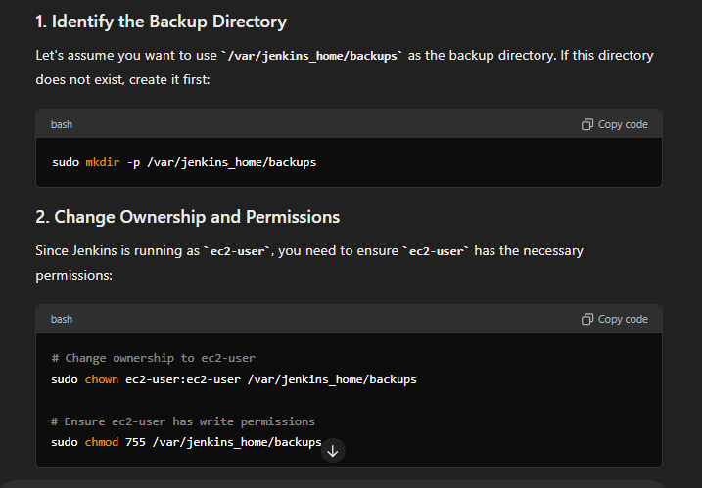

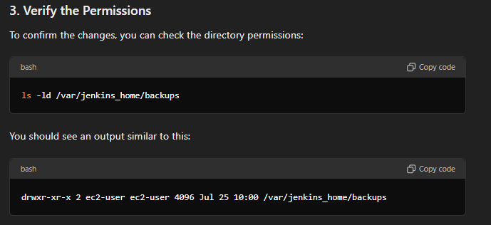

**Now go to Jenkins Dashboard> manage Jenkins> Tools and Actions > ThinBackup > click on Backup Now**

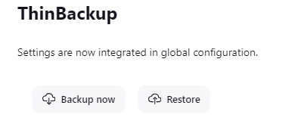

**Now to check backup is created or not go to SSH Terminal**

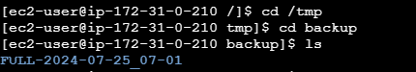

**Here backup file is found.**